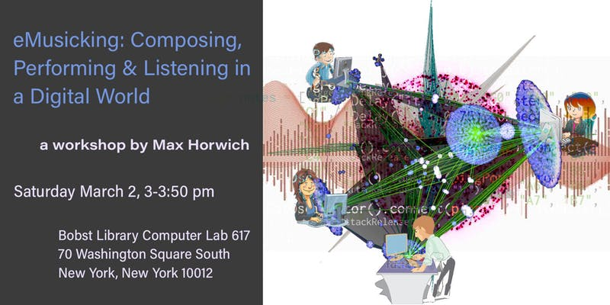

*eMusicking* is a participatory, open-ended workshop on a participatory, open-ended field of study. This 50-minute workshop (which assumes no prior musical knowledge and only basic computer literacy) explores the effect of technology on the interconnected practices of composing, performing, and listening to music.

The material is examined through work of socio-musicologist Christopher Small, who coined the term *musicking* to describe music as an active process (i.e. a verb), rather than a finished product (a noun). The composer, performer, and audience all have equally important roles in the act of musicking, and all the more so when the lines between those roles are blurred -- as they are in the works discussed in class and the piece performed as a group activity in the second half of the class.

**PART 1: Lecture/Discussion (~25 minutes)**

The first half of the class is spent discussing three seminal works of music from the 20th century avant garde. Each focuses on one of the aforementioned roles -- composing, performing, and listening -- while also paying heed to its connection to the other aspects of the musicking experience. These three works are not meant to be comprehensive or canonical, and could comfortably be replaced by other works to better suit the needs of the class, but for now I will focus on the workshop as I have taught it thus far.

**Listening (5-10 minutes)**

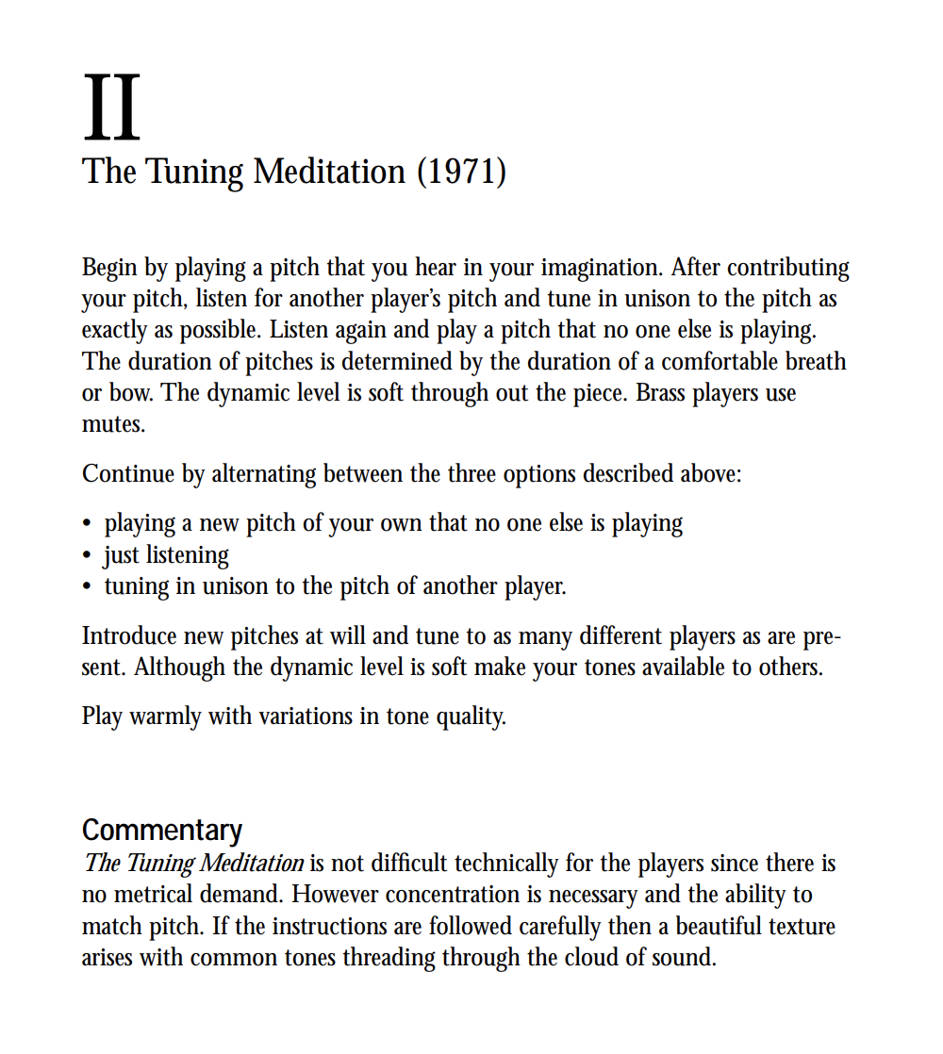

We begin our discussion with Pauline Oliveros, whose practice of *deep listening* will be useful to students in appreciating the role of the audience member as active participant. The class performs a brief rendition of Oliveros’ *Tuning Meditation* (1971), followed by a discussion of the work. Opening with this piece serves a dual function, on one hand serving as a classroom “icebreaker,” getting students out of their seats, breathing deeply and paying close attention to each other’s voices; and on the other, emphasising that there is no music without a “listener,” and that listening (which any student, regardless of musical background, will have some experience with) is as integral to the experience of music as composing or performing (with which they are less likely to have experience).

**Composing (5-10 minutes)**

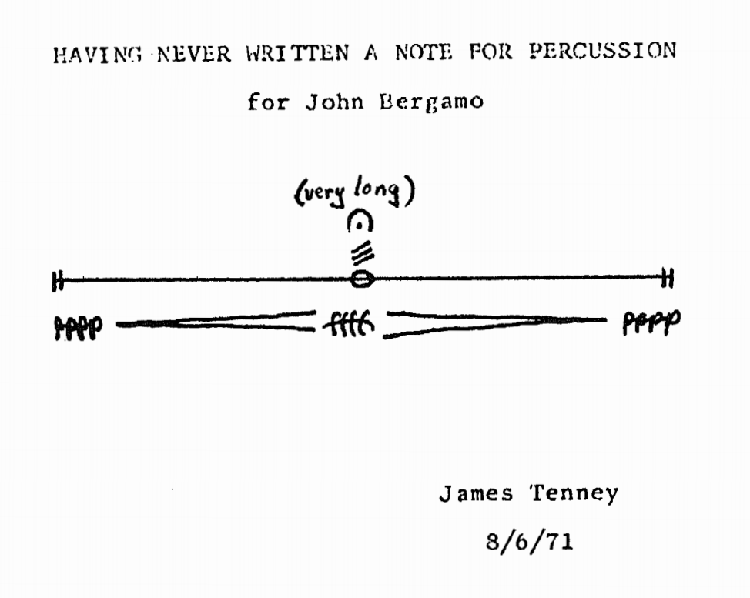

The class then moves on to James Tenney and his composition *Having Never Written a Note for Percussion* (1971). Having discussed the written score for *Tuning Meditation*, students will now discuss a score that more closely resembles a musical score as they may have previously understood it (sheet music with notation), and how formal training is not necessarily a prerequisite for creating such a document. We will discuss what is, and more importantly, what is not specified by the score (i.e. instrumentation, specific duration), and what that leaves up to the performer.

**Performing (5-10 minutes)**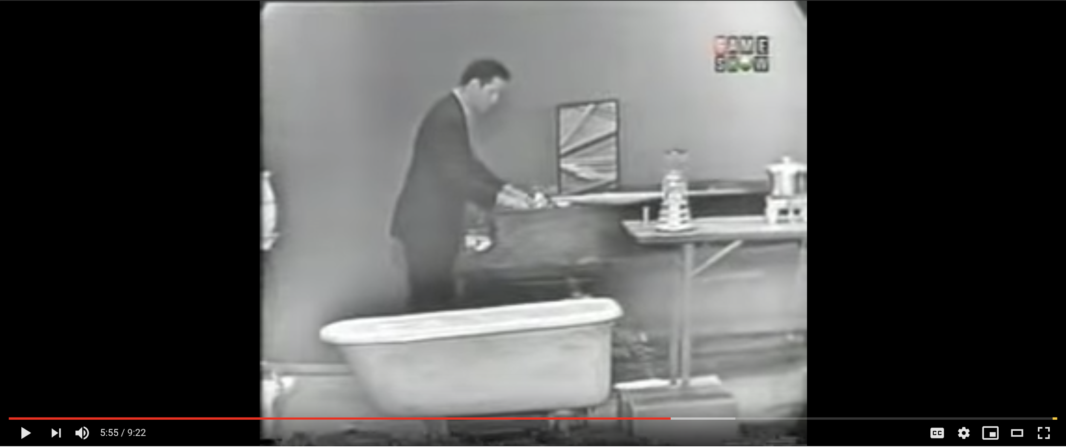

Finally, the class will examine John Cage’s *Water Walk* (1959), and more specifically the 1960 performance of the piece on the game show *I’ve Got a Secret*. Central to this discussion will be the role of the audience for this piece (i.e. how does the audience’s reaction color the meaning of the piece?), and the medium of delivery (a nationally televised game show) as an essential component to the message conveyed by the performer.

**PART 2: Group Activity (*~25 minutes*)**

The second half of the workshop is dedicated to what participant feedback has almost unanimously identified as “the fun part.” Students are given a simple prompt for a musicking in the style we have discussed in class:

*Everyone calls into a conference line and turns on speaker phone.*

*What happens next?*

After a brief demonstration of feedback between two phones on speaker in close proximity, students are invited to collaboratively compose a piece for the workshop to perform together. This is broken down roughly into brainstorming, composing, performing, and discussing.

**Brainstorming (5 minutes)**

Write down everyone’s ideas. Ask questions to coax out creativity, but be as unobtrusive as possible. Everything that gets written down should come directly from students.

**Composing (5 minutes)**

Focus in on the items from brainstorming that were best received by the group and organize them into a coherent, performable structure. The instructor can take a slightly more active role here, but should still stick primarily to asking leading questions (e.g. how does it start? How does it end? Do we all come in at once? etc.) rather than proposing specific solutions.

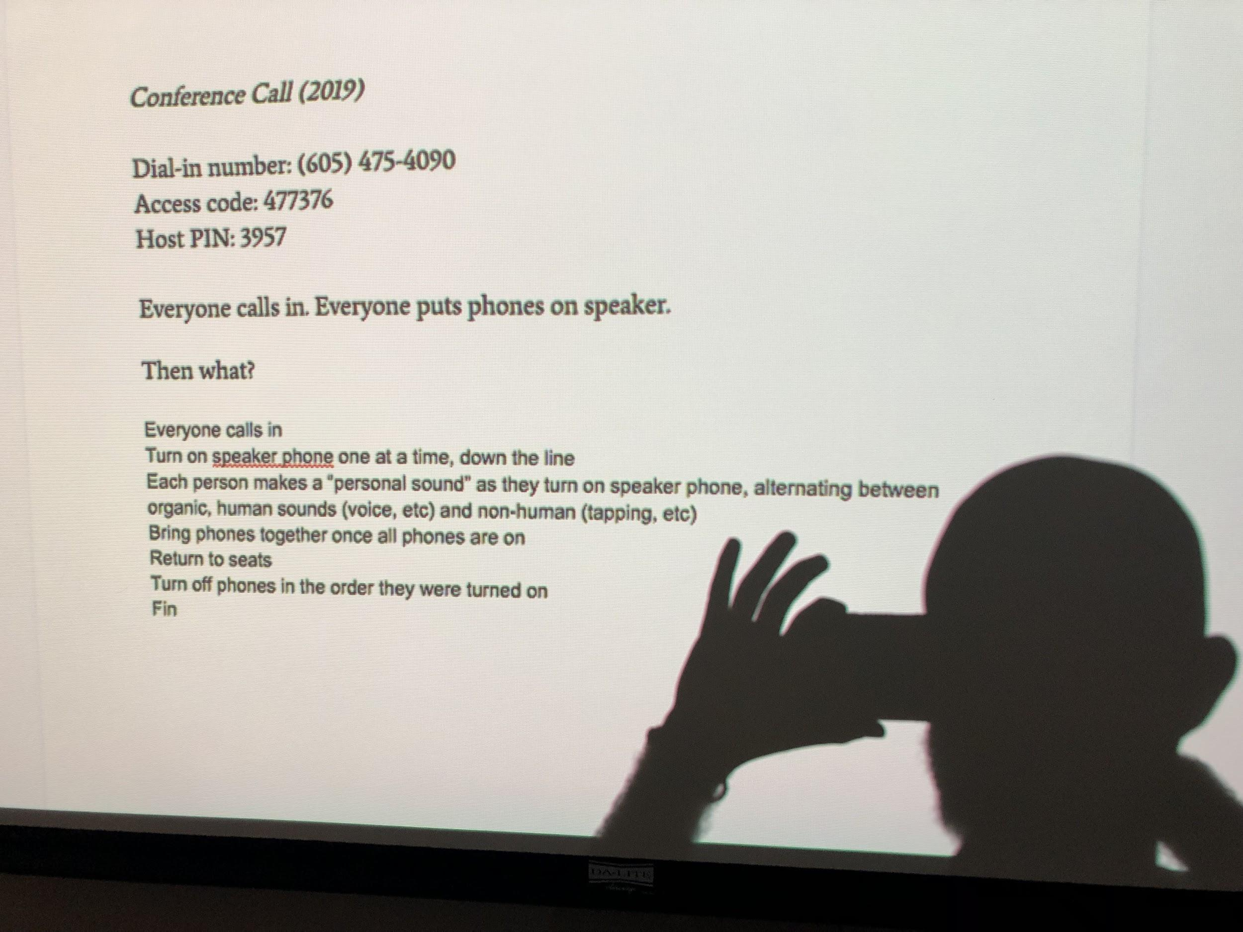

**Performance (5-10 minutes)**

We do the thing. Students will probably veer off from the score we just wrote, but that’s okay.

[Video of workshop performance](https://vimeo.com/322419056)

**Discussion (remaining time)**

Ask students for final thoughts. Drive home the overarching theme that music is meant to be engaging and interactive, and that every person, regardless of experience or training, has something to contribute to the musical discourse.

---------

**Addendum / Personal Thoughts:**

The initial run of this workshop was an outlet for me to actualize a set of theories I’m still struggling to articulate. I’ve been practicing or studying experimental music in one form or another for two decades now, so I’m bringing more baggage into this class than I could possibly hope to unpack in less than an hour.

The musical works discussed in the first half of the workshop could probably be replaced with other examples that engage more directly with the explicitly contemporary focus of the class. However, I have found these works illuminating in my own study and practice, and I believe their relevance comes into focus once the class arrives at the group activity. Students reported a clearer understanding of the first half following the second, which drives home my point that active creative engagement is the best inroad to this material.